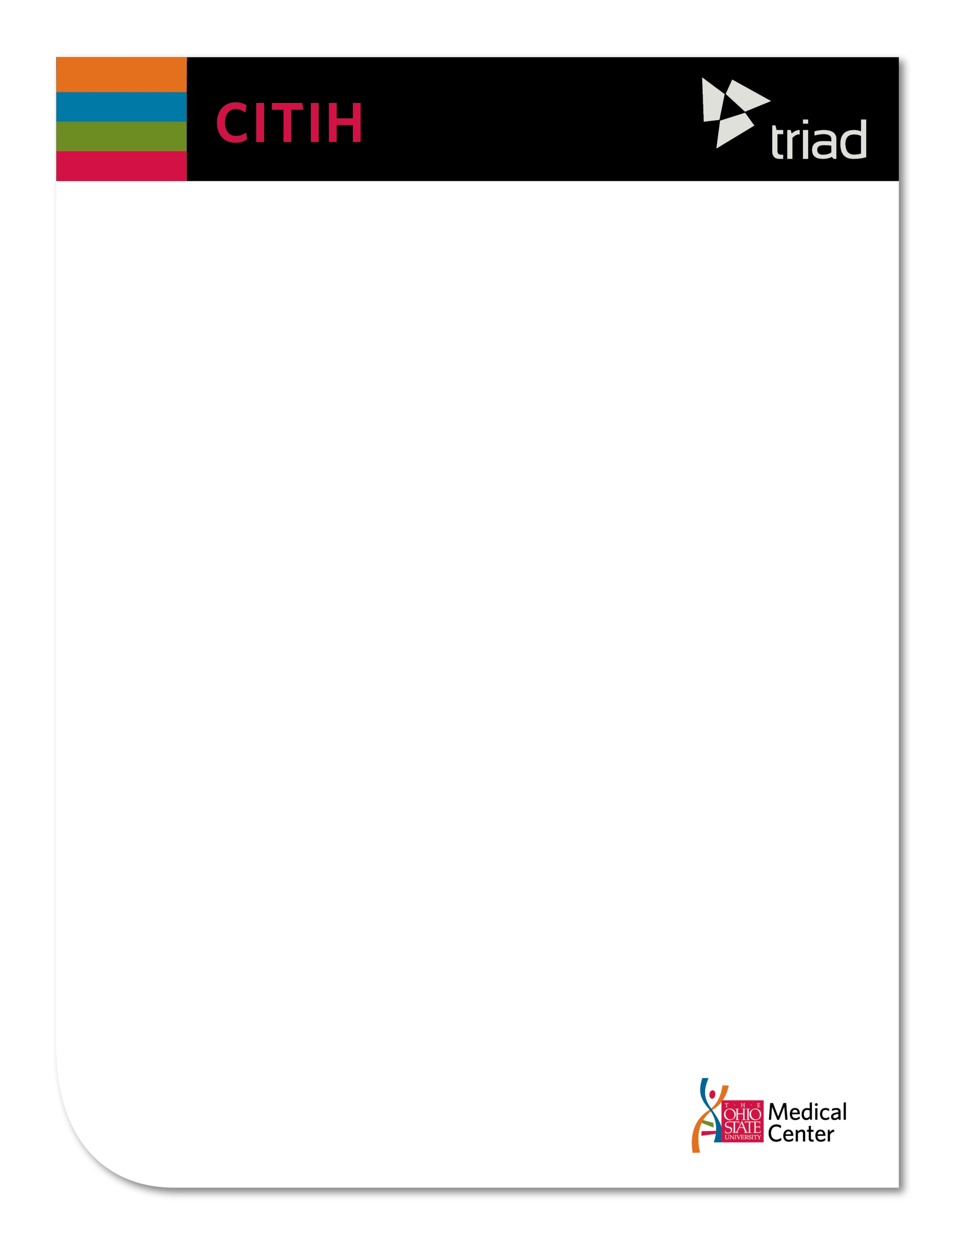

**The Triad system is the middleware that creates a scalable, secure and knowledge-anchored data sharing environment**

TRIAD addresses the need to collect, store, integrate, analyze, and report upon heterogeneous and distributed data sets spanning organizational boundaries. Multidisciplinary and team-based clinical and translational research programs often encounter challenges such as:

* Physically disparate community participants.
* Multi-institutional security and data interoperability issues.
* Training and change-management overhead.
* Complex federal and local data integrity and privacy constraints.

TRIAD addresses these needs and challenges by allowing for the creation of a scalable, secure, and knowledge anchored data sharing environment, building upon the robust caGrid infrastructure that was initially designed for the National Cancer Institute’s caBIG program.

Researchers and institutions can maintain locus of control of their own data and decide with whom and in what contexts it is shared. TRIAD enables federated research and data management so that researchers may ask and answer impactful and timely questions.

Data service creation workflow with TRIAD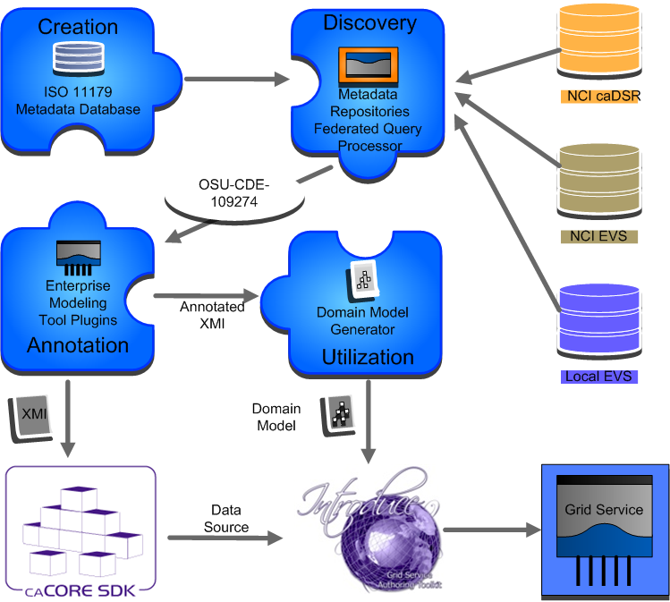

The TRIAD data service creation workflow extensively leverages the openMDR, a federated ISO 11179 metadata repository developed with the express purpose of enabling institutions to develop and maintain their own unique semantic library while interoperating with repositories and systems. This enables researchers to create, curate, and iteratively build their own data models specific to their problem domain without a large administrative burden. Simple, powerful tools for querying the openMDR and annotating models directly in the tools which create them make the TRIAD data service creation workflow streamlined and agile.

Specific services, infrastructure, and software components provided by the TRIAD community include:

* Training, testing, and deployment instances of the TRIAD middleware.
* Fully documented and easy-to-deploy instances of the core TRIAD middleware.
* A collaborative community wiki and GForge site.
* A collection of best-practice and technical documentation to support a full spectrum of TRIAD deployment, adoption, and adaptation scenarios.

http://triadcommunity.org

http://citih.osumc.edu